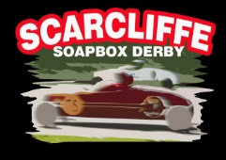  Sponsorship and  Gift Aid Declaration Form |  | 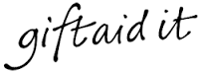

Please sponsor me (name):
To: | Race in the Scarcliffe Soapbox Derby
In aid of (tick): | Ashgate Hospice Clic Sargent

If I have ticked the box headed ‘Gift Aid? √’, I confirm that I am a UK Income or Capital Gains taxpayer. I have read this statement and want the charity or Community Amateur Sports Club (CASC) named above to reclaim tax on the donation detailed below, given on the date shown. I understand that I must pay an amount of Income Tax and/or Capital Gains Tax in the tax year at least equal to the amount of tax that all the charities and CASCs I donate to, will reclaim on my gifts for that tax year. I understand that other taxes such as VAT and Council Tax do not qualify. I understand the charity will reclaim 25p of tax on every £1 that I have given.
Remember: Full Name + Home Address + Postcode + =

Full Name  (Fist name and surname) | Home Address  (Only needed if you are Gift Aiding your donation) | Postcode | Amount (£) | Date Paid | Gift Aid
Total Donations Received |  |  | £
Total Gift Aid Donations |  |  | £
Date Donations Given to Charity or CASC |  |  | £

